

NBA Analytics Dashboard: Multi-Award Prediction, Player Similarity, and

Performance Insights Using Machine Learning
a mini-project report submitted by

KERSEN JONATHAN NELSON NAVAMANI RAJ - URK23CS1081
in partial fulfillment for the award of the degree of

BACHELOR OF TECHNOLOGY
in

COMPUTER SCIENCE AND ENGINEERING
under the supervision of

Dr. S. Salaja, M.E., Ph.D


DIVISION OF COMPUTER SCIENCE AND ENGINEERING SCHOOL OF COMPUTER SCIENCE AND TECHNOLOGY APRIL 2026

DIVISION OF COMPUTER SCIENCE AND ENGINEERING

BONAFIDE CERTIFICATE

Certified that this mini project report titled “NBA Analytics Dashboard : Multi-Award prediction , Player Similarity and Performance Insights using Machine Learning ” is the Bonafide work of KERSEN JONATHAN NELSON NAVAMANI RAJ (URK23CS1081) who carried out the mini project work under my supervision.

Dr. S. Salaja, M.E., Ph.D
Associate Professor

Submitted for the Project Viva Voce held on 15.04.2026

Examiner

ACKNOWLEDGEMENT

First and foremost, I thank and praise the Almighty God for His abundant blessings, grace, and guidance, which have strengthened me with the willpower and confidence to successfully carry out my mini project.
I express my sincere gratitude to our beloved founders, Late Dr. D. G. S. Dhinakaran, C.A.I.I.B., Ph.D., and Dr. Paul Dhinakaran, M.B.A., Ph.D., for their love, vision, and continual prayers that inspire and motivate me.
I am deeply thankful to Dr. R. Elijah Blessing, Ph.D., our Honorable Vice Chancellor, and Dr. S. J. Vijay, Ph.D., our Respected Registrar, for providing me with this valuable opportunity to undertake the mini project.
I convey my heartfelt thanks to Dr. G. Jaspher W. Kathrine, M.E., Ph.D., Head of the Division, Department of Computer Science and Engineering, for their continuous encouragement and guidance.
I owe my sincere gratitude to Dr. S. Salaja, M.E., Ph.D for their invaluable guidance, support, and motivation throughout the completion of this project.
My sincere thanks also go to all the faculty members of the Division of Computer Science and Engineering for their assistance and cooperation.
Finally, I extend my heartfelt appreciation to my parents and friends for their prayers, encouragement, and constant support during the course of my mini project.

ABSTRACT

The rapid growth of sports data and digital media has created a demand for intelligent platforms that can efficiently collect, analyze, and present real-time information in a unified manner. Existing sports applications primarily focus on live scores or basic statistics, often lacking advanced analytical capabilities, predictive insights, and system reliability during data outages. Additionally, dependence on single external data sources can lead to inconsistencies, delays, or system failures, affecting user experience and decision-making.
To address these limitations, this project proposes an NBA Analytics Dashboard (NBA Hub) that integrates live sports data with advanced analytics and predictive modeling within a scalable web-based system. The proposed platform combines real-time data acquisition with a robust fallback mechanism to ensure continuous availability of information. It provides features such as live game tracking, standings, news aggregation, player statistics, and team comparisons, all within a unified and interactive interface.
The system incorporates machine learning techniques, including logistic regression for Most Valuable Player (MVP) prediction, cosine similarity for player and season comparison, and composite scoring with normalization for impact ranking. These analytical modules enable users to gain deeper insights into player performance and team dynamics. Furthermore, the system employs a “live-first with fallback” strategy, where data is fetched from external APIs and automatically supplemented by locally stored database information in case of failures, ensuring reliability and consistency.
The development of the system is carried out using a modern full-stack architecture, with a React-based frontend for dynamic visualization, FastAPI microservices for backend processing, and a PostgreSQL database for efficient data storage and retrieval. Performance optimization techniques such as caching and precomputation are implemented to enhance responsiveness.
In conclusion, the NBA Analytics Dashboard provides a comprehensive, intelligent, and reliable platform for sports analytics by integrating real-time data with advanced machine learning models. It addresses the shortcomings of traditional sports applications and offers an improved user experience through accurate insights, system resilience, and scalable design.
Table of Contents

Chap. No | Title | Page No
 | ABSTRACT
1 | Introduction | 7
 | 1.1 Introduction | 7
2 | Literature Survey | 9
 | 2.1 Introduction to Literature Survey | 9
 | 2.2 Existing Systems / Applications | 9
 | 2.3 Techniques Used in sports Analysis | 11
 | 2.4 Comparative Analysis | 12
 | 2.5 Research Gap | 13
3 | Proposed Methodology | 14
 | 3.1 Overview of the Proposed System | 15
 | 3.2 System Architecture | 13
 | 3.3 Modules Description | 17
 | 3.4 Workflow / Process Flow | 18
 | 3.5 Technologies Used | 18
4 | Implementation | 21
 | 4.1 Overview of Implementation | 21
 | 4.2 Frontend Implementation | 21
 | 4.3 Backend Implementation | 22
 | 4.4 Database Implementation | 24
 | 4.5 Machine Learning Implementation | 24
 | 4.6 Integration and Testing | 25

5 | Results and Discussion | 26
 | 5.1 Overview of Results | 26
 | 5.2 System Outputs / Results | 26
 | 5.3 Performance and Analysis | 32
 | 5.4 Discussion | 33
 | 5.5 Limitations | 33
6 | Conclusion and Future Scope | 31
 | 6.1 Conclusion | 31
 | 6.2 Future Scope | 35
 | REFERENCES | 36

CHAPTER 1 – INTRODUCTION

The rapid advancement of digital technologies and the growing popularity of professional sports have led to an exponential increase in the availability of sports data. In modern basketball, particularly in the National Basketball Association (NBA), vast amounts of data are generated from games, player performances, team statistics, and media coverage. This surge in data has created a demand for intelligent systems that can efficiently process, analyze, and present meaningful insights to users. While numerous sports applications exist today, most of them primarily focus on providing live scores, basic statistics, or news updates, offering limited capabilities for deeper analysis and predictive insights.
Existing sports platforms such as score-tracking websites and mobile applications provide users with features like real-time game updates, standings, player statistics, and highlights. Although these features are useful for general consumption, they often lack advanced analytical tools that can help users understand player performance trends, compare players across seasons, or predict future outcomes such as award winners. Additionally, these systems are heavily dependent on external data sources, which can sometimes be unreliable due to API rate limits, network failures, or data inconsistencies, resulting in incomplete or delayed information.
Another significant challenge in sports data platforms is ensuring system reliability and performance. Since most applications rely solely on live data feeds, any disruption in external APIs can lead to blank pages or missing data, negatively impacting user experience. Furthermore, many existing systems do not incorporate efficient data caching or fallback mechanisms, making them unsuitable for consistent performance during high-demand scenarios or offline demonstrations. This highlights the need for a more robust and resilient system that can maintain functionality even when live data sources are unavailable.
To address these challenges, this project introduces the NBA Analytics Dashboard (NBA Hub), a comprehensive web-based platform designed to integrate live sports data with advanced analytics and predictive modeling. The proposed system combines real-time data acquisition with a “live-first with fallback” strategy, ensuring continuous data availability and system stability. It provides a unified interface for accessing live scores, standings, news, player profiles, team comparisons, and statistical leaders, thereby enhancing the overall user experience.
In addition to real-time data integration, the system incorporates machine learning and analytical techniques to deliver deeper insights. Logistic regression is used to predict Most Valuable Player (MVP) probabilities based on player performance metrics, while cosine similarity is applied to identify comparable player seasons and career patterns. Furthermore, a composite scoring mechanism with normalization is used to compute impact rankings, enabling users to evaluate player contributions more effectively. These analytical features transform raw sports data into actionable insights, supporting better understanding and decision-making.
The system is developed using a modern full-stack architecture, with a React-based frontend for dynamic and interactive user interfaces, FastAPI microservices for backend processing, and a PostgreSQL database for efficient data storage and retrieval. Performance optimization techniques such as caching and precomputation are implemented to ensure fast response times and scalability. The modular design of the system also allows for future enhancements, such as advanced visualizations, user personalization, and additional predictive models.
The proposed NBA Analytics Dashboard is designed to be scalable, reliable, and user-friendly, making it suitable for sports enthusiasts, analysts, and researchers. It bridges the gap between traditional sports applications and advanced analytics platforms by combining live data, machine learning, and system reliability into a single unified solution. By doing so, it enhances data accessibility, improves analytical capabilities, and ensures a seamless user experience.
Overall, this project aims to provide a significant advancement in sports analytics by addressing the limitations of existing systems and introducing a more intelligent, resilient, and data-driven approach to analyzing basketball performance and trends.

CHAPTER 2 – LITERATURE SURVEY

INTRODUCTION TO LITERATURE SURVEY

The literature survey provides an overview of existing sports analytics systems and technologies related to the proposed NBA Analytics Dashboard. It examines current applications that offer features such as live scores, player statistics, standings, and news updates, along with the techniques used for data analysis and performance evaluation.
Studying these systems helps identify their strengths and limitations. Most existing platforms focus on basic information display and lack advanced analytics such as predictive modeling, similarity analysis, and comprehensive performance insights. Additionally, many systems depend heavily on external data sources without reliable fallback mechanisms, which can affect system stability.
This chapter highlights the gaps in current solutions and establishes the need for a more integrated and intelligent platform. The proposed system aims to address these limitations by combining real-time data, machine learning-based analytics, and a reliable “live-first with fallback” approach.

EXISTING SYSTEMS / APPLICATIONS

Sports Score Applications (ESPN, NBA App, FlashScore)

Sports score applications such as ESPN, NBA App, and FlashScore are widely used for tracking live games, scores, and standings. These platforms provide real-time updates, match schedules, player statistics, and news, making them essential for sports enthusiasts.
From a technological perspective, these systems rely on live data feeds and centralized servers to deliver real-time updates. They are optimized for speed and user experience, ensuring quick access to game information and highlights.
However, these applications have certain limitations. They mainly focus on delivering live information rather than advanced analytics. Features such as predictive modeling, player similarity analysis, and deeper performance evaluation are generally not available. Additionally, these systems depend heavily on live data sources, and any disruption in APIs can lead to delays or incomplete data display.

Sports Analytics Websites (Basketball Reference, NBA Stats)

Platforms like Basketball Reference and NBA Stats provide detailed historical and advanced statistics for players and teams. These websites offer extensive datasets, including season averages, advanced metrics, and career records.
These systems use structured databases and statistical models to present large volumes of data in an organized format. They are valuable for researchers and analysts who require in-depth statistical information.
Despite their strengths, these platforms lack interactivity and real-time integration. They primarily provide static or periodically updated data rather than live analytics. Furthermore, they do not include predictive features such as MVP probability estimation or automated similarity comparisons, limiting their usefulness for dynamic analysis.

Fantasy Sports Platforms (DraftKings, FanDuel)

Fantasy sports platforms such as DraftKings and FanDuel allow users to create virtual teams and compete based on real player performances. These platforms incorporate basic statistical analysis and projections to assist users in decision-making.
Technologically, these systems use data aggregation, scoring algorithms, and basic predictive models to enhance user engagement. They are designed to provide interactive experiences and competitive gameplay.
However, their primary focus is on gaming rather than comprehensive analytics. The insights provided are often limited to fantasy scoring rather than real-world performance evaluation. Additionally, these platforms do not offer detailed analytical tools such as similarity engines, impact rankings, or integrated dashboards combining multiple data sources.

TECHNIQUES USED IN SPORTS ANALYSIS

Sports analytics techniques play a crucial role in transforming raw game and player data into meaningful insights. One of the primary methods used in this project is Logistic Regression, which is applied to predict the probability of a player winning the Most Valuable Player (MVP) award. It analyzes multiple performance features such as points, efficiency, and team success to estimate the likelihood of selection.
Another important technique is Cosine Similarity, which is used to compare player performances across seasons or careers. It measures the similarity between players based on their statistical profiles, enabling users to identify players with comparable playing styles or performance levels. To improve accuracy, league-adjusted normalization is applied to reduce bias across different seasons.
Composite Scoring with Normalization is used for calculating player impact rankings. This technique combines multiple performance metrics such as efficiency, usage, and team contribution into a single score. Z-score normalization is applied to ensure fair comparison across players and seasons, resulting in more balanced and meaningful rankings.
Data Preprocessing and Normalization are essential steps in preparing the dataset for analysis. Player statistics are scaled and standardized to ensure that different features contribute proportionally to the models. This improves the performance and reliability of machine learning algorithms.
Additionally, Caching and Precomputation Techniques are used to enhance system performance. Expensive computations such as similarity calculations are precomputed and stored in the database, allowing faster API responses and improved user experience.
These techniques collectively enable the system to provide deeper insights, accurate predictions, and efficient data processing, making the NBA Analytics Dashboard a powerful tool for sports analysis.
Sports analytics techniques play a crucial role in transforming raw game and player data into meaningful insights. One of the primary methods used in this project is Logistic Regression, which is applied to predict the probability of a player winning the Most Valuable Player (MVP) award. It analyzes multiple performance features such as points, efficiency, and team success to estimate the likelihood of selection.
Another important technique is Cosine Similarity, which is used to compare player performances across seasons or careers. It measures the similarity between players based on their statistical profiles, enabling users to identify players with comparable playing styles or performance levels. To improve accuracy, league-adjusted normalization is applied to reduce bias across different seasons.
Composite Scoring with Normalization is used for calculating player impact rankings. This technique combines multiple performance metrics such as efficiency, usage, and team contribution into a single score. Z-score normalization is applied to ensure fair comparison across players and seasons, resulting in more balanced and meaningful rankings.
Data Preprocessing and Normalization are essential steps in preparing the dataset for analysis. Player statistics are scaled and standardized to ensure that different features contribute proportionally to the models. This improves the performance and reliability of machine learning algorithms.
Additionally, Caching and Precomputation Techniques are used to enhance system performance. Expensive computations such as similarity calculations are precomputed and stored in the database, allowing faster API responses and improved user experience.
These techniques collectively enable the system to provide deeper insights, accurate predictions, and efficient data processing, making the NBA Analytics Dashboard a powerful tool for sports analysis.

COMPARATIVE ANALYSIS

Feature / System | ESPN/NBA | Stats Websites | Fantasy Platforms | Proposed System
Live scores | Yes | No | Limited | Yes
Player statistics | Basic | Detailed | Moderate | Advanced
Predictive Analysis | No | No | Limited | Yes
Player similarity | No | No | No | Yes

Impact Ranking | No | No | No | Yes
Machine Learning Support | No | No | Limited | Yes
System Reliability | Moderate | High | Moderate | Yes (Fallback enabled)
Data Storage | Centralized | Centralized | Centralized | Centralized + Fallback DB
The comparison shows that existing systems focus on specific functionalities such as live updates, historical statistics, or fantasy gaming. While some platforms provide detailed data or limited projections, none offer a fully integrated system combining real-time data, advanced analytics, and predictive modeling.
The proposed NBA Analytics Dashboard (NBA Hub) overcomes these limitations by integrating live data with machine learning techniques such as MVP prediction, similarity analysis, and impact ranking. Additionally, the inclusion of a “live-first with fallback” strategy ensures higher system reliability compared to existing platforms.
Thus, the proposed system provides a more comprehensive, intelligent, and reliable solution for sports analytics.

RESEARCH GAP

The analysis of existing systems reveals several important gaps in current sports analytics platforms. Firstly, there is no unified system that combines real-time data with advanced analytics and predictive modeling. Most applications focus either on live scores or historical statistics, without offering deeper insights such as player similarity or performance predictions.
Secondly, the lack of intelligent automation is a major limitation. Existing platforms do not incorporate machine learning techniques like MVP prediction or impact ranking, which restricts analytical depth and user understanding.Another key issue is system reliability. Many platforms depend entirely on external data sources, making them vulnerable to API failures and data inconsistencies.
Finally, the absence of integrated and scalable architectures limits the overall user experience. These gaps highlight the need for a system that combines live data, advanced analytics, and a reliable fallback mechanism, which is addressed by the proposed NBA Analytics Dashboard.

CHAPTER 3 – PROPOSED METHODOLOGY

OVERVIEW OF THE PROPOSED SYSTEM
The proposed system is an AI-enabled sports analytics platform designed to provide real-time NBA data along with advanced analytical insights. It integrates live data sources with machine learning techniques and a robust backend architecture to ensure reliability, performance, and scalability. The system enables users to access live scores, standings, news, player statistics, and team comparisons through a unified and interactive dashboard.
The core objective of the system is to combine real-time data acquisition with intelligent analytics. Initially, data is fetched from external sources such as sports APIs and NBA content delivery networks. This data is then processed and structured for efficient usage within the system. Analytical techniques are applied to transform raw data into meaningful insights, including player performance evaluation, statistical comparisons, and predictive modeling.
A key feature of the system is the implementation of a “live-first with fallback” strategy. The system first attempts to retrieve live data from external APIs. If the data is unavailable due to network issues or API limitations, it automatically switches to locally stored database records or cached data. This ensures uninterrupted functionality and prevents blank or incomplete outputs, thereby enhancing system reliability.
The system also incorporates machine learning models to provide deeper analytical capabilities. Logistic regression is used for MVP prediction, cosine similarity is applied for player comparison, and composite scoring techniques are used for impact ranking. These models enable users to gain advanced insights into player performance and trends.
Overall, the proposed system acts as a comprehensive sports analytics platform that combines live data, machine learning, and reliable system design. It provides a scalable and efficient solution for analyzing basketball data while ensuring a seamless and consistent user experience.

SYSTEM ARCHITECTURE

The proposed system follows a layered architecture consisting of five primary components: frontend, backend, database, analytics module, and data integration layer. This architecture ensures scalability, modularity, and reliable data processing.
The frontend is developed as a web-based dashboard using React. It allows users to view live scores, standings, news, player profiles, team comparisons, and analytics results such as MVP predictions and similarity insights. It acts as the interaction layer between the user and the system, providing an intuitive and responsive interface.
The backend is implemented using FastAPI microservices and serves as the central processing unit. It handles API requests, data fetching, processing, and communication between different modules. The backend is divided into multiple services, including MVP prediction, similarity analysis, and impact ranking, ensuring modular and efficient processing.
The database (PostgreSQL) stores structured player and team data, including season statistics, similarity results, and impact scores. It also acts as a fallback source when live data is unavailable, ensuring consistent system performance.
The analytics module applies machine learning and statistical techniques to generate insights. Logistic regression is used for MVP prediction, cosine similarity for player comparison, and composite scoring with normalization for impact ranking. These models transform raw sports data into meaningful analytical outputs.
The data integration layer is responsible for fetching live data from external sources such as NBA APIs, content delivery networks, and RSS feeds. A key feature of this layer is the “live-first with fallback” strategy, where the system first retrieves live data and automatically switches to cached or database data if live sources fail.
The overall architecture of the system is illustrated in Figure 3.1, which shows the interaction between the frontend, backend services, analytics module, database, and external data sources.

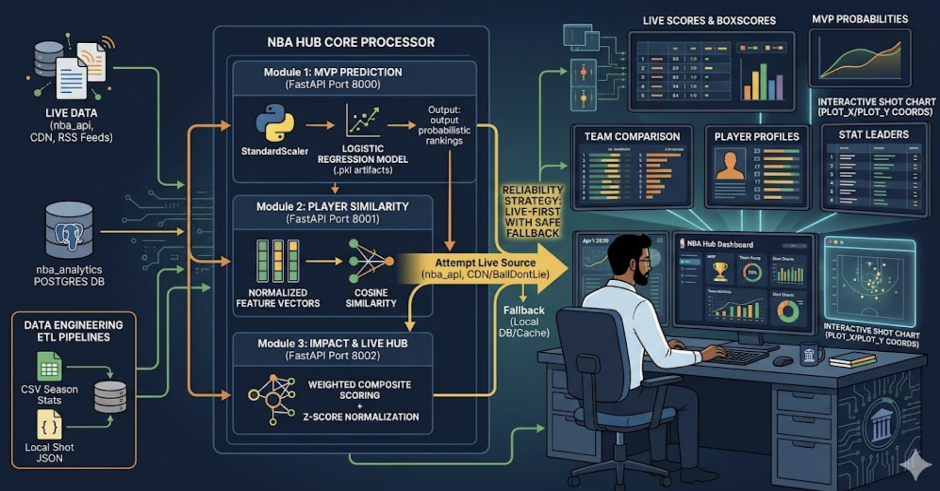

Figure 3.1: System Architecture of NBA Analytics Dashboard (NBA Hub)

MODULES DESCRIPTION
The proposed system is divided into several functional modules, each responsible for a specific task within the workflow.

Live Data Integration Module
This module handles the collection of real-time NBA data from external sources such as APIs, content delivery networks, and RSS feeds. It retrieves information related to live scores, standings, news, and player statistics. The module ensures that data is continuously updated and available for further processing.

Data Processing and Storage Module
This module is responsible for cleaning, transforming, and storing data in a structured format. It processes raw data received from external sources and organizes it into database tables such as player statistics and team performance records. The PostgreSQL database ensures efficient storage and retrieval of information.

MVP Prediction Module
This module uses machine learning techniques, specifically logistic regression, to predict the probability of players winning the Most Valuable Player (MVP) award. It analyzes multiple performance metrics such as points, efficiency, and team success to generate probability rankings.

Player Similarity Module
This module identifies players with similar performance profiles using cosine similarity. It compares statistical features of players across seasons and provides a list of similar players. Precomputed similarity results are stored in the database for faster response times

Impact Ranking Module
This module calculates player impact scores using a composite scoring method. It combines multiple performance metrics and applies normalization techniques to generate fair and meaningful rankings. The module supports both overall and star-player-based rankings.

Frontend Visualization Module
This module provides an interactive web-based dashboard for users. It displays live scores, standings, news, player profiles, team comparisons, and analytical results. The user interface is designed to be responsive and user-friendly, enhancing overall experience.
7. Reliability and Fallback Module
This module ensures system stability through a “live-first with fallback” strategy. It first attempts to fetch live data and automatically switches to cached or database data if live sources fail. This prevents data loss and ensures uninterrupted system functionality.
8. API Communication Module
This module manages communication between the frontend and backend services using REST APIs. It ensures efficient data transfer, handles requests and responses, and integrates different system components seamlessly.

WORKFLOW / PROCESS FLOW

The system follows a structured workflow to ensure efficient data processing, analysis, and reliable output.
The process begins when the user interacts with the frontend dashboard, which sends requests for data such as live scores, standings, news, or player statistics. These requests are handled by the backend through REST APIs.
The backend retrieves data from external sources such as NBA APIs, content delivery networks, and RSS feeds. The data is then cleaned, processed, and converted into a structured format suitable for analysis and storage.
Next, the analytics modules process the data. The MVP Prediction module calculates player probabilities, the Player Similarity module identifies comparable players, and the Impact Ranking module evaluates overall performance using composite scoring techniques.If live data is unavailable, the system automatically switches to cached or database data using a “live-first with fallback”mechanism, ensuring continuous system functionality.Finally, the processed data is sent to the frontend and displayed through interactive dashboards and visualizations. The system continuously updates data to provide users with accurate and up-to-date insights.
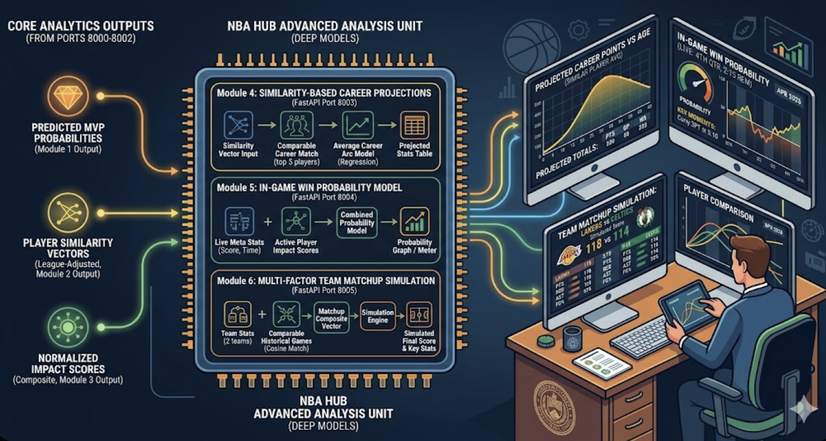

Figure 3.2: Data Flow and Analytics Workflow in the NBA Analytics Dashboard

TECHNOLOGIES USED

The proposed system utilizes a combination of modern technologies to achieve efficient data processing, analytics, and visualization. The frontend is developed using React with Vite, providing an interactive and responsive user interface for displaying live scores, statistics, and analytical insights.
The backend is implemented using FastAPI, which supports efficient REST API handling and seamless integration with machine learning components. The system follows a microservices architecture, where different APIs handle functionalities such as MVP prediction, player similarity, and impact ranking.
PostgreSQL is used as the database for storing structured data, including player statistics, similarity results, and impact scores. It also serves as a fallback data source to ensure system reliability when live data is unavailable.
The analytics module is developed using Python, along with libraries such as Pandas and NumPy for data processing, and Scikit-learn for implementing machine learning models like logistic regression and similarity analysis.
For live data integration, the system uses the nba_api library, along with NBA CDN and RSS feeds to fetch real-time scores, standings, and news. Additional services such as TheSportsDB are used for player images and media content.
The integration of these technologies results in a scalable and efficient system that combines web development, real-time data integration, and machine learning to deliver an intelligent sports analytics platform.

CHAPTER 4 – IMPLEMENTATION

OVERVIEW OF IMPLEMENTATION
The implementation of the proposed system focuses on developing a full-stack web application that integrates real-time NBA data, machine learning-based analytics, and a reliable backend architecture. The system is designed using a modular approach, where each component is developed independently and later integrated to form a complete workflow.
The application follows a client-server architecture, where the frontend provides an interactive dashboard for user interaction, and the backend handles data processing, API communication, and integration with analytics modules and the database. The implementation ensures efficient handling of live data, accurate analysis using machine learning techniques, and consistent system performance through fallback mechanisms.
The system is developed in multiple stages, including frontend development using React, backend API implementation using FastAPI, database integration with PostgreSQL, and development of analytics modules such as MVP prediction, player similarity, and impact ranking. Additionally, live data integration from external sources is incorporated to provide real-time updates.
Each module is tested individually to ensure correctness and performance, and then integrated into the complete system. The final implementation ensures seamless interaction between components, providing users with a fast, reliable, and intelligent sports analytics platform.

FRONTEND IMPLEMENTATION

The frontend of the system is developed using modern web technologies to provide a responsive and user-friendly interface. It acts as the primary interaction layer between the user and the system.
The interface is built using React with Vite, which enables the creation of dynamic components and efficient state management. The application includes multiple views such as the dashboard, live scores, standings, news section, player profiles, team comparison, and analytics panels. Users can explore real-time game data, view player statistics, and access advanced analytics such as MVP predictions and similarity results.
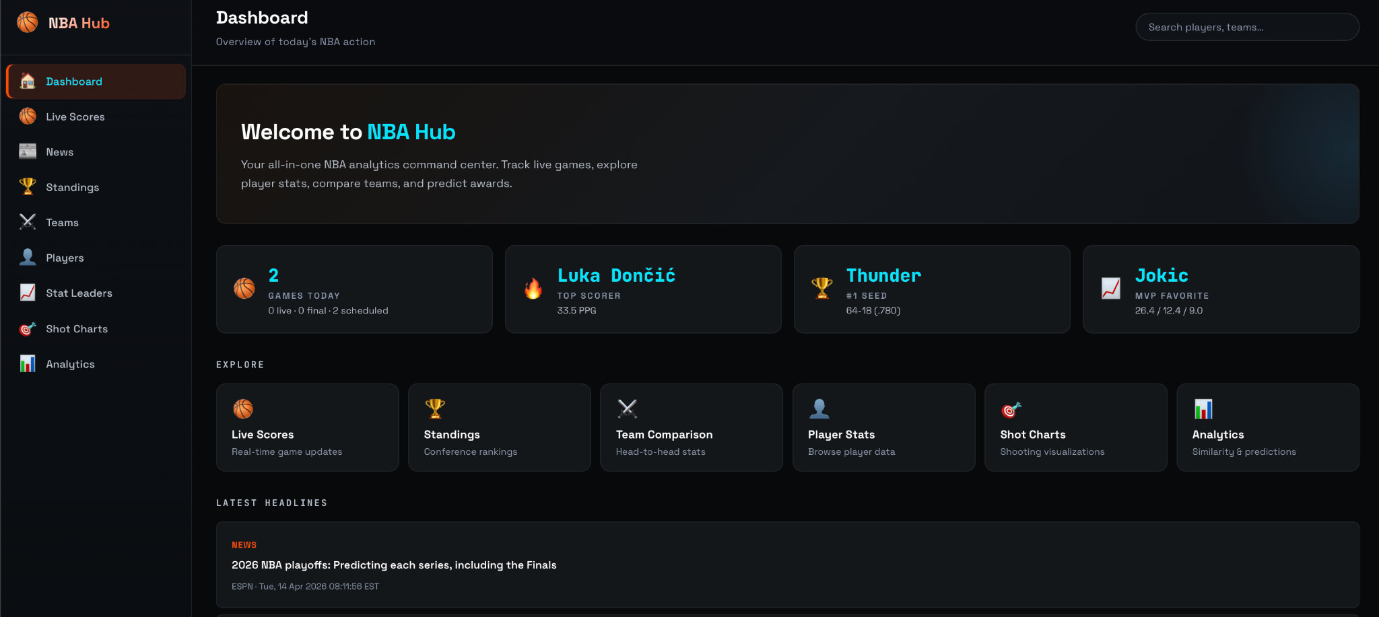

Figure 4.1: Figure 4.1: Dashboard Interface of the NBA Analytics Dashboard (NBA Hub)

Styling is implemented using custom CSS to create a consistent dark-themed analytics dashboard. The interface presents data through cards, tables, and charts, making it easy for users to understand performance trends and insights.
Routing and navigation are handled efficiently to ensure smooth transitions between different sections of the application. The frontend communicates with the backend through REST APIs to fetch live and processed data, which is then displayed dynamically on the dashboard.
Overall, the frontend is designed to provide a seamless and interactive experience, enabling users to easily access and analyze NBA data in real time.

BACKEND IMPLEMENTATION

The backend is implemented using FastAPI, which provides a high-performance framework for building RESTful APIs. It acts as the core processing unit of the system and manages all server-side operations.
The backend handles requests from the frontend, retrieves live data from external sources, and communicates with the database. It provides API endpoints for features such as live scores, standings, news, player profiles, MVP predictions, similarity analysis, and impact rankings.
The system follows a modular microservices approach, where different APIs handle specific functionalities. Data validation is implemented to ensure accurate and consistent processing.
Additionally, the backend uses a “live-first with fallback” strategy, switching to cached or database data if live sources are unavailable. The asynchronous nature of FastAPI enables efficient handling of multiple requests, improving system performance.

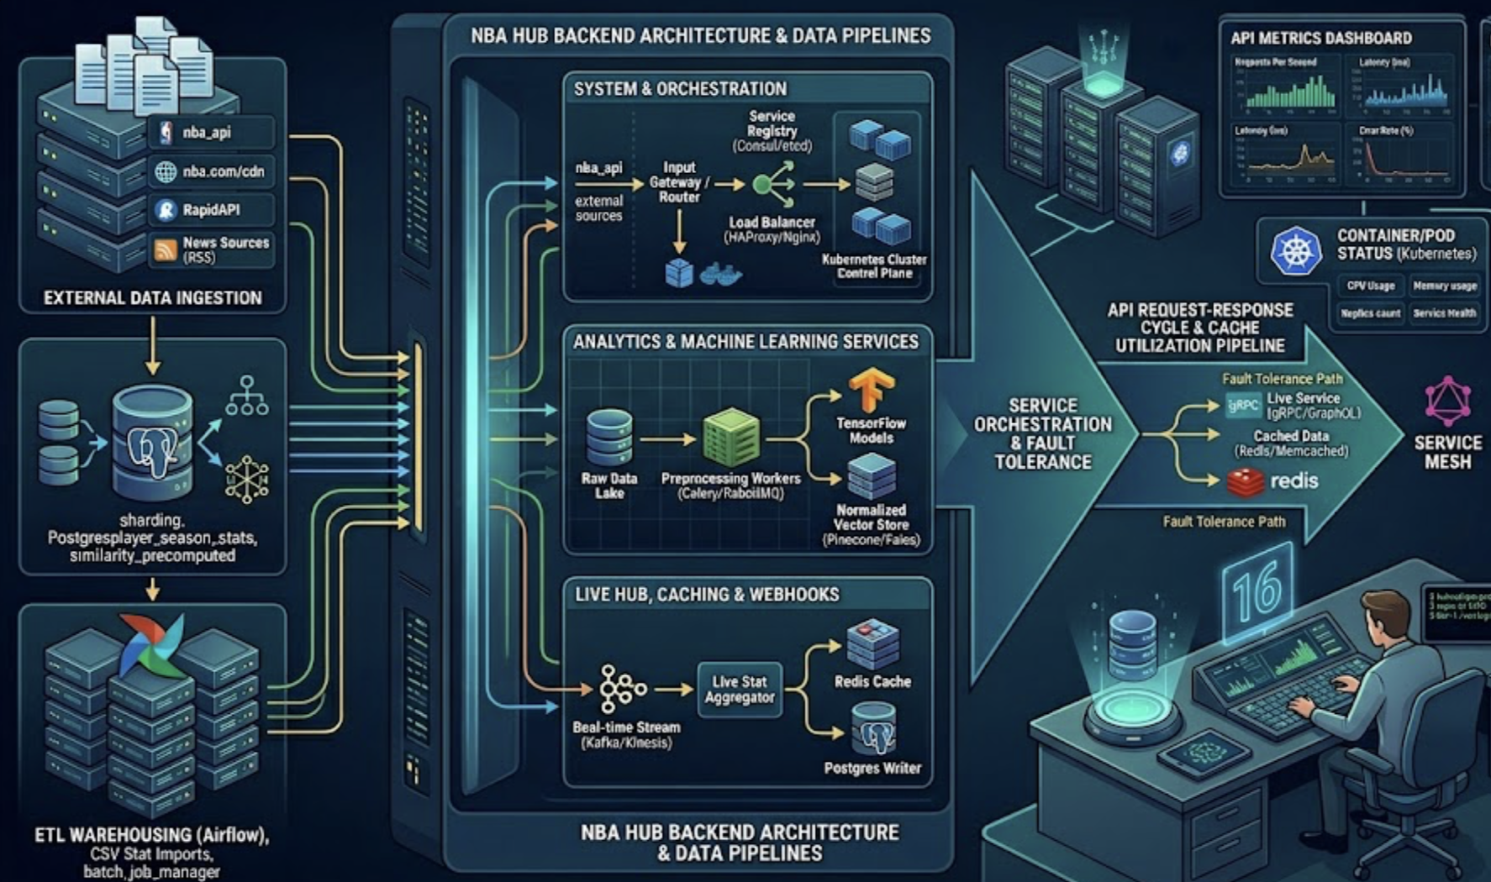

Figure 4.2: Backend API Communication Flow

DATABASE IMPLEMENTATION

The system uses PostgreSQL as the database for storing structured sports data and application-related information. The database stores player statistics, team data, similarity results, and impact scores.
Tables are designed to manage relationships between players, teams, and seasons. Each record includes attributes such as player name, season, team, performance metrics (points, rebounds, assists), and advanced statistics used for analytics.
Additional tables are used to store precomputed similarity results and impact scores, enabling faster retrieval and improved performance. The database also acts as a fallback source when live data is unavailable.
The database ensures efficient storage and fast retrieval of data, supporting real-time analytics and smooth visualization in the dashboard.

MACHINE LEARNING IMPLEMENTATION

The machine learning component is implemented using Python and Scikit-learn, and is responsible for generating analytical insights from player and team data.
Logistic Regression is used for MVP prediction. It analyzes multiple performance features such as points, efficiency, usage rate, and team success to estimate the probability of a player winning the MVP award.
Cosine Similarity is used to compare player performances across seasons. Player statistics are converted into normalized feature vectors, and similarity scores are calculated to identify players with comparable performance profiles.
Composite Scoring with Normalization is used for impact ranking. Multiple performance metrics are combined into a single score, and z-score normalization is applied to ensure fair comparison across players and seasons.
The models are trained using historical player data and preprocessed datasets. To improve performance and response time, similarity results and impact scores are precomputed and stored in the datab

INTEGRATION AND TESTING

The integration phase combines all modules into a unified system. The frontend, backend microservices, database, and analytics modules are connected through well-defined APIs to ensure smooth communication.
Testing is performed at multiple levels, including unit testing, integration testing, and system testing. Functional testing ensures that features such as live scores, standings, player profiles, and analytics modules work correctly. Performance testing verifies that the system can handle multiple requests efficiently.
The analytics outputs, including MVP predictions, similarity results, and impact rankings, are validated to ensure accuracy and consistency. The reliability of the system is also tested by simulating API failures and verifying the effectiveness of the fallback mechanism.
The final system demonstrates seamless interaction between all components, providing accurate analytics, real-time data updates, and a reliable user experience.

CHAPTER 5 – RESULTS AND DISCUSSION

OVERVIEW OF RESULTS

The proposed NBA Analytics Dashboard (NBA Hub) was successfully implemented and tested to evaluate its functionality and performance. The system integrates real-time NBA data, machine learning-based analytics, and a reliable backend architecture into a unified platform. All modules, including live data integration, MVP prediction, player similarity, impact ranking, and frontend visualization, were tested and validated.
The system effectively retrieves and processes live data such as game scores, standings, news, and player statistics, and presents them through an interactive dashboard. The analytics modules generate meaningful insights, including MVP probability rankings, player comparisons, and performance-based impact scores.
The implementation of the “live-first with fallback” strategy ensures system reliability by maintaining data availability even when external sources fail. This significantly improves user experience compared to traditional sports applications that rely solely on live APIs.
The results demonstrate that the system provides enhanced data accessibility, deeper analytical insights, and improved reliability. Overall, the proposed system offers a comprehensive and efficient solution for real-time sports analytics and performance evaluation.

SYSTEM OUTPUTS / RESULTS

The system generates outputs that help users analyze NBA data efficiently.
The dashboard provides an overview of live games, standings, and key player statistics using clear visual components. Detailed sections display player profiles, team data, and statistical leaders.
Analytics outputs such as MVP predictions, player similarity, and impact rankings offer deeper insights into performance. The results are presented in a structured and user-friendly format, enabling easy understanding and analysis.

TThe system output includes real-time data responses and fallback status, confirming that the data has been successfully retrieved and processed. This feature ensures reliability by maintaining data availability even when live sources fail, and guarantees that users receive consistent and accurate information at all times.

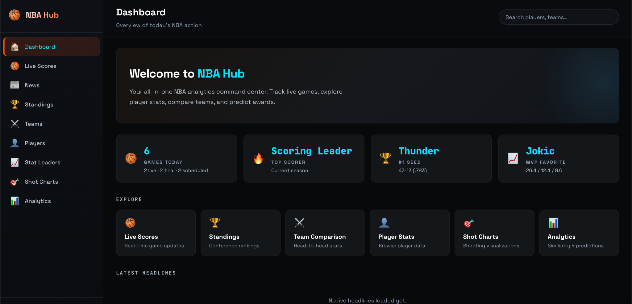
Figure 5.1: Dashboard

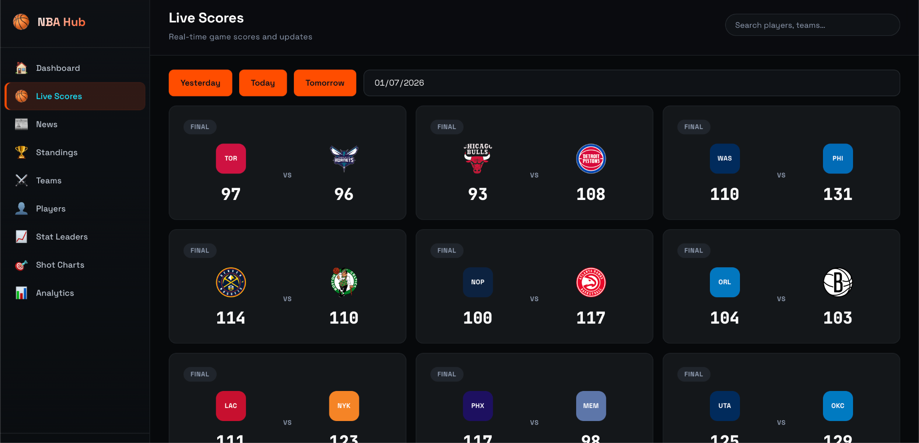

Figure 5.2: This figure shows the live scores page displaying real-time NBA game results. Users can view match outcomes, scores, and switch between dates such as yesterday, today, and tomorrow.

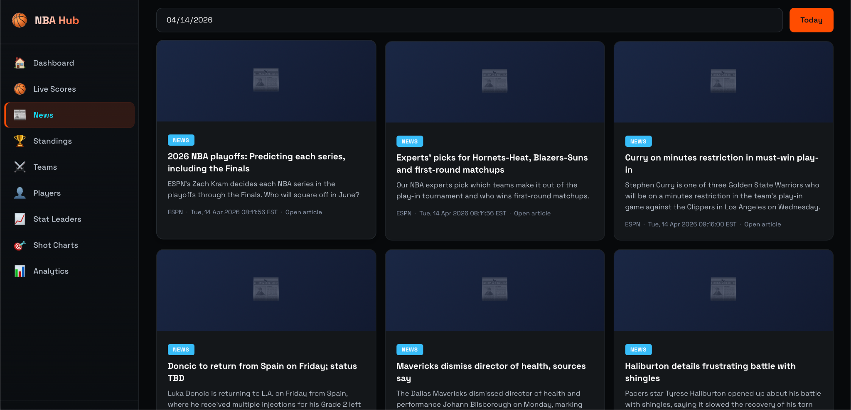

Figure 5.3: News Section Interface
This figure illustrates the news module, where users can view the latest NBA headlines. News articles are fetched dynamically and displayed in a structured card format.

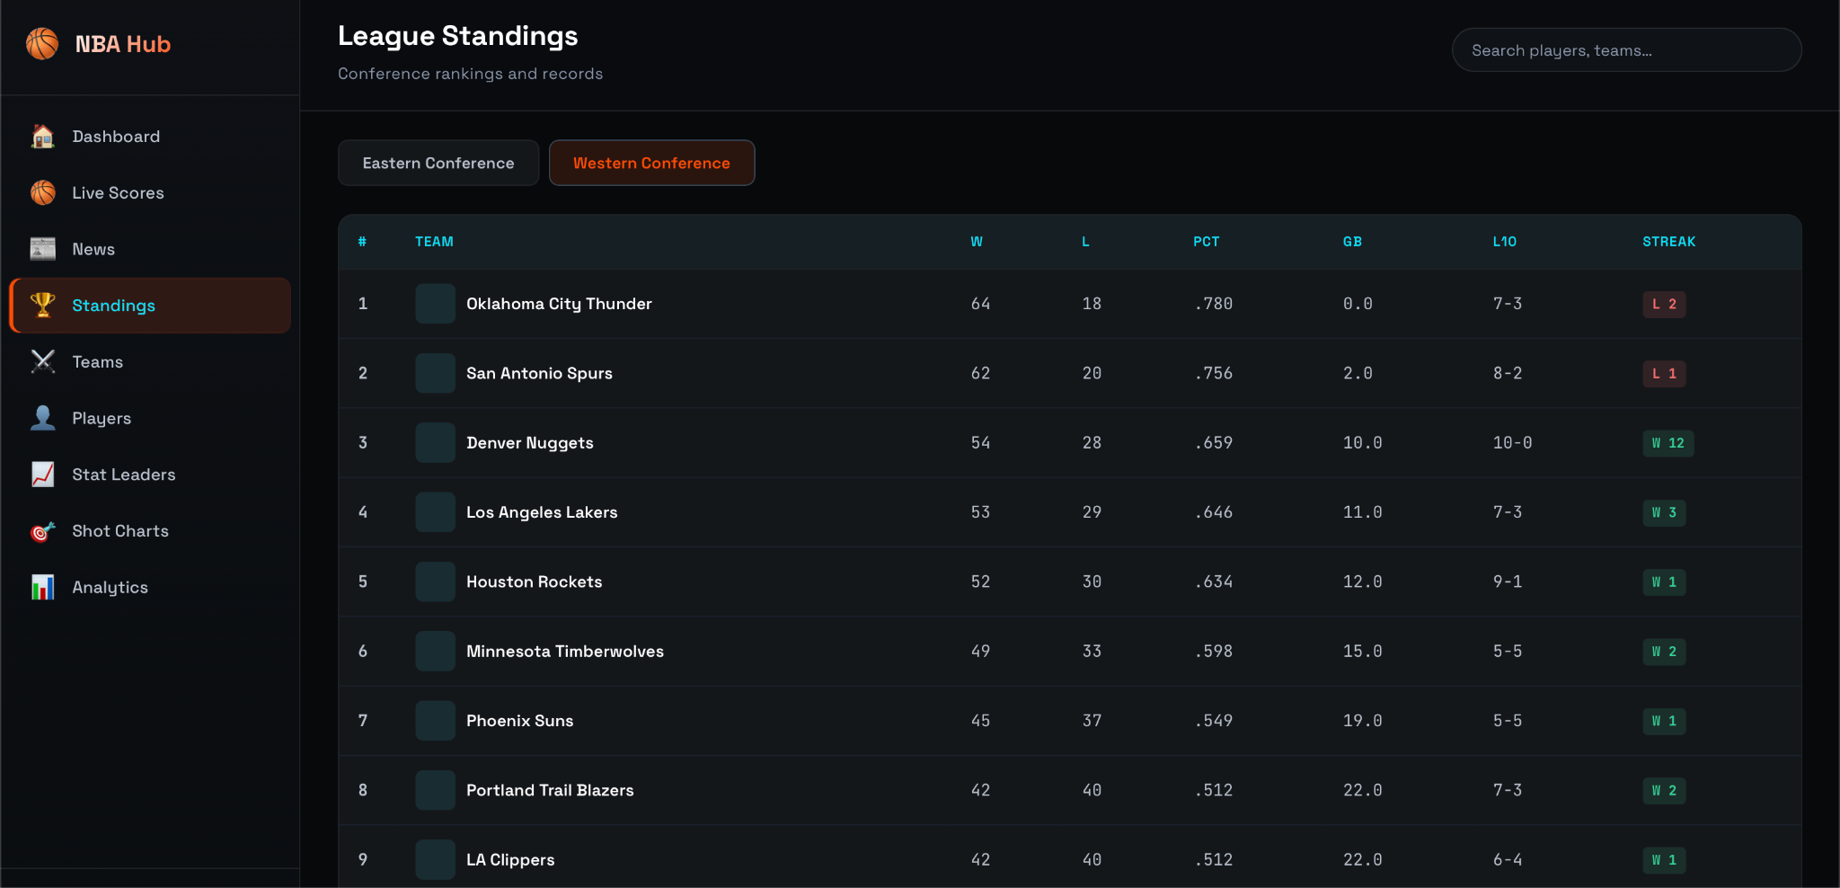

Figure 5.4: League Standings Interface
This figure shows the standings page displaying team rankings in Eastern and Western conferences. It includes statistics such as wins, losses, percentage, and streak.
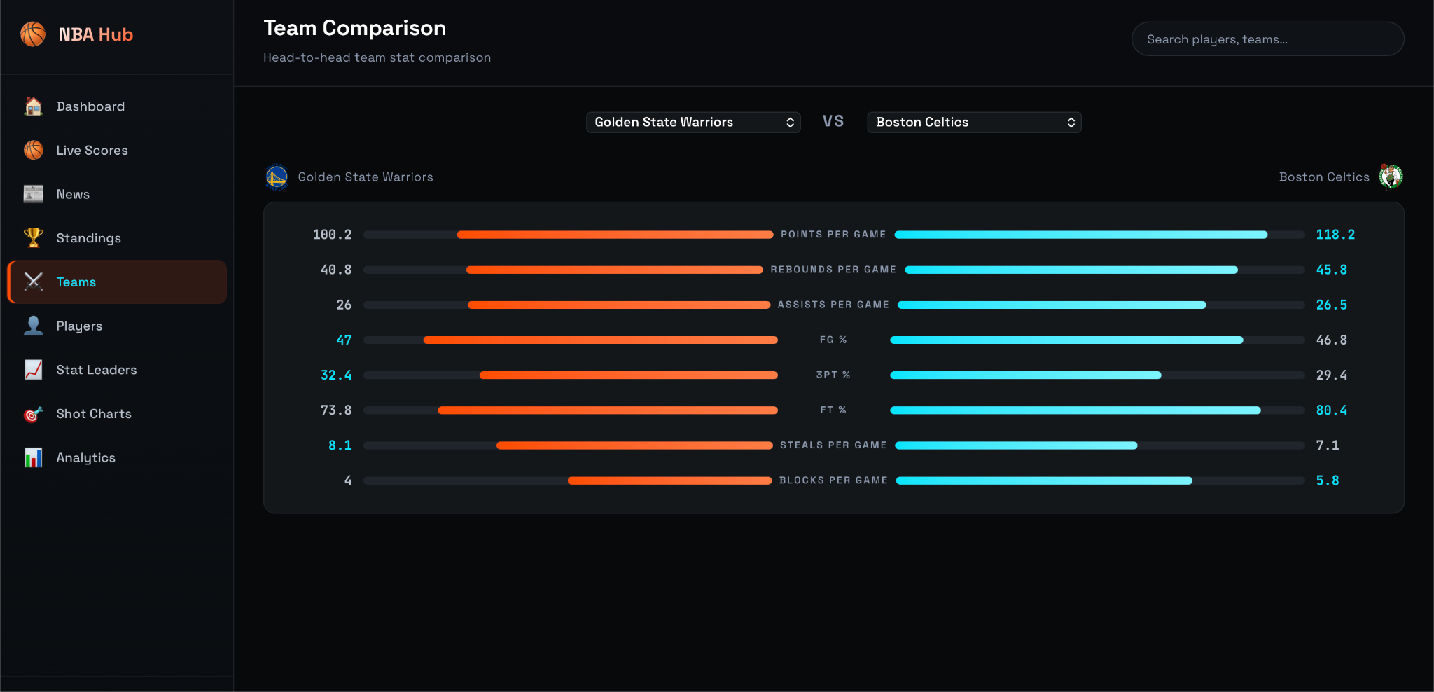

Figure 5.5: Team Comparison Interface
This figure presents the team comparison module, allowing users to compare two teams based on performance metrics such as points, rebounds, assists, and shooting percentages.

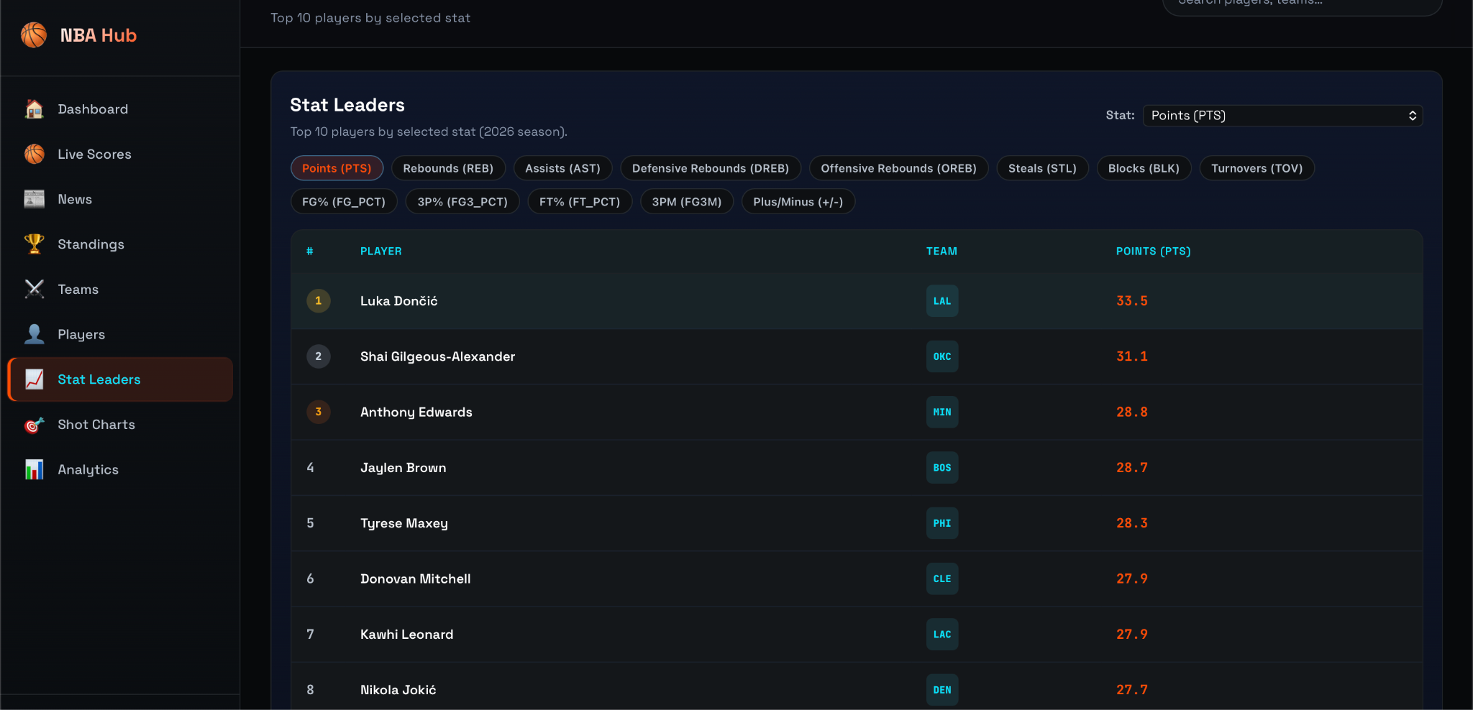

Figure 5.7: Stat Leaders Interface
This figure illustrates the stat leaders module, where top players are ranked based on selected statistics such as points, rebounds, and assists.

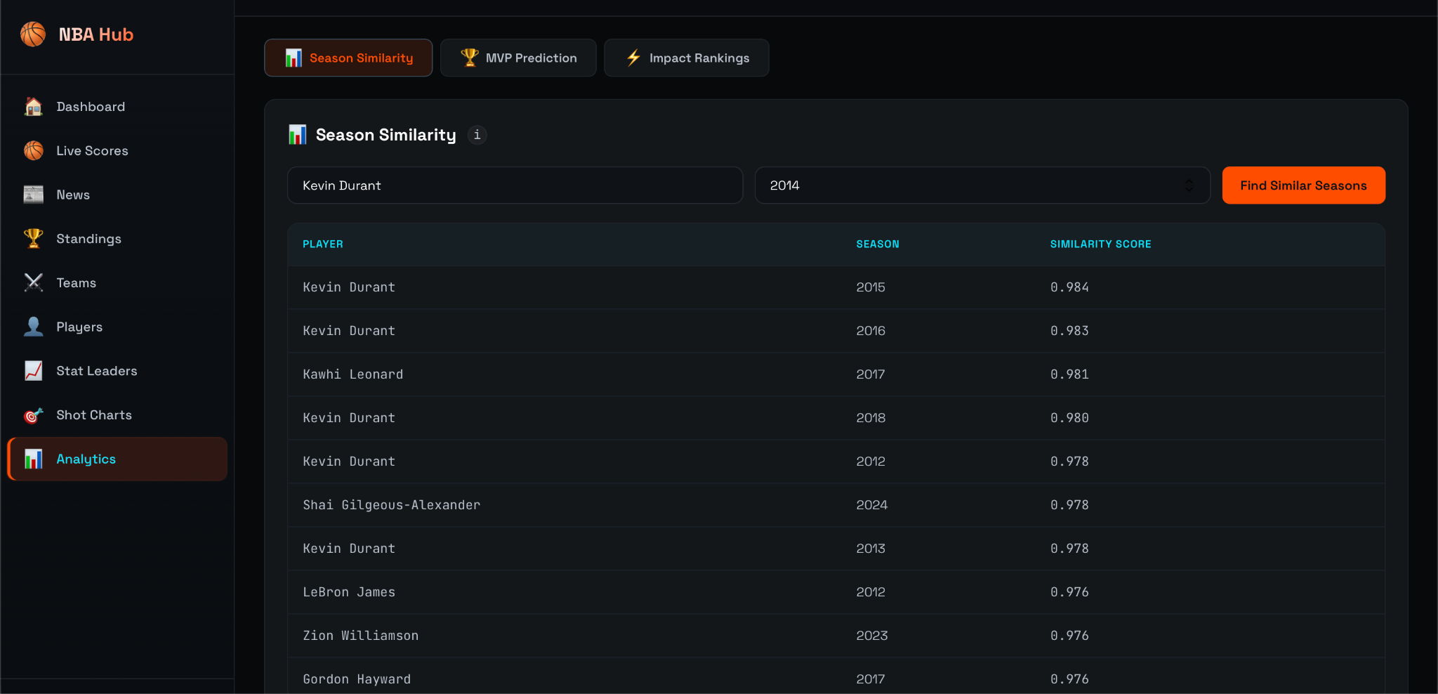

Figure 5.8: Season Similarity Analysis
This figure shows the player similarity feature, where users can find seasons similar to a selected player based on statistical comparison.
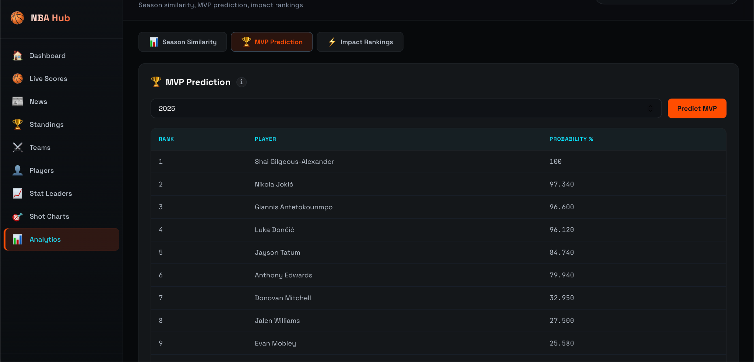

Figure 5.9: MVP Prediction Interface
This figure presents the MVP prediction module, displaying players ranked by their probability of winning the MVP award based on machine learning analysis.

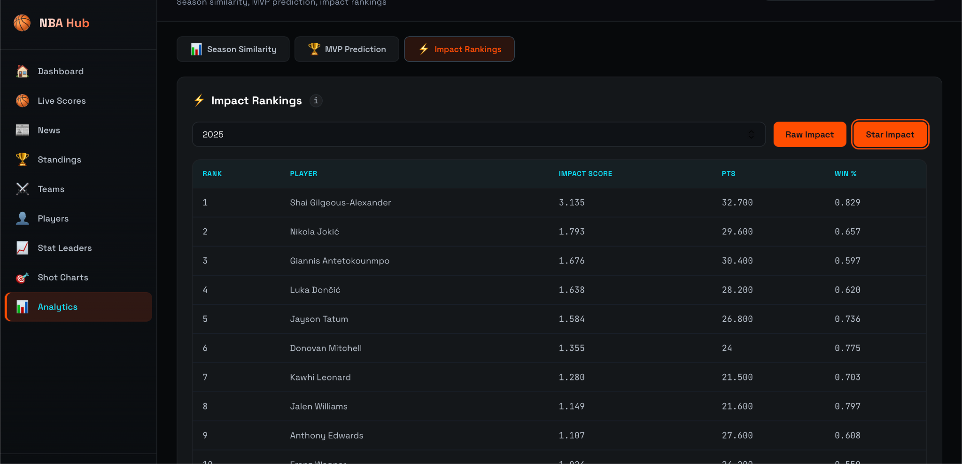

Figure 5.10: Impact Ranking Interface
This figure shows the impact ranking module, where players are ranked based on composite performance scores, including metrics such as points and win percentage.

PERFORMANCE AND ANALYSIS

The performance of the system was evaluated based on accuracy, efficiency, and usability. The analytics modules demonstrated good accuracy in generating insights such as MVP predictions, player similarity, and impact rankings using historical player data.
The system processes data efficiently, with minimal delay in fetching, analyzing, and displaying results. The use of precomputed similarity data and caching techniques improves response time and overall performance.
The “live-first with fallback” mechanism enhances reliability by ensuring continuous data availability even when external APIs fail. This significantly improves system stability compared to traditional sports applications.
The user interface is responsive and easy to navigate, providing a smooth experience across different modules such as live scores, standings, and analytics.
Overall, the system achieves a balance between performance, accuracy, and reliability, delivering fast and meaningful insights for NBA data analysis.

DISCUSSION

The results demonstrate that the proposed system effectively addresses the limitations identified in existing sports analytics platforms. Unlike traditional systems that focus only on live scores or basic statistics, the proposed system provides advanced analytical insights through machine learning techniques.
The integration of analytics modules enables features such as MVP prediction, player similarity, and impact ranking, offering deeper understanding of player performance and trends. This reduces dependency on multiple platforms and provides a unified analytical experience.
A key advantage of the system is the implementation of a “live-first with fallback” mechanism. While most existing applications rely solely on external APIs, the proposed system ensures continuous data availability by switching to cached or database data when needed, improving reliability and user experience.
The combination of real-time data integration and machine learning creates a comprehensive solution that enhances data accessibility, analytical depth, and system stability. This makes the system more advanced and practical compared to existing solutions discussed in the literature survey.

LIMITATIONS

Despite its advantages, the system has certain limitations. The accuracy of the analytics models depends on the quality and completeness of the underlying data. Incomplete or inconsistent data from external sources may affect prediction and analysis results.
The system relies on external APIs for live data, which may be subject to rate limits, delays, or changes in data structure. This can impact real-time data retrieval despite the fallback mechanism.
The current analytics modules provide meaningful insights but can be further enhanced with more advanced models and deeper statistical analysis. Additionally, some features such as shot charts are still in the development stage and require more comprehensive datasets.
The system is designed primarily for demonstration and individual use, and may require further optimization and deployment strategies for large-scale production environments.
These limitations provide opportunities for future improvements and enhancements.

CHAPTER 6 – CONCLUSION AND FUTURE SCOPE

CONCLUSION

The proposed NBA Analytics Dashboard (NBA Hub) was successfully designed and implemented to address the limitations of existing sports analytics platforms. The system integrates real-time data processing, machine learning-based analytics, and a reliable backend architecture to provide a comprehensive solution for analyzing NBA data.
The developed system enables users to access and explore live game data, player statistics, standings, and news through an interactive dashboard. Advanced analytics modules such as MVP prediction, player similarity, and impact ranking provide deeper insights into player performance and trends, enhancing user understanding.
One of the key contributions of this project is the implementation of a “live-first with fallback” mechanism, which ensures continuous data availability even when external sources fail. This significantly improves system reliability and user experience compared to traditional applications.
The results demonstrate that the system improves data accessibility, analytical capability, and overall performance. By combining real-time data integration with machine learning techniques, the project provides a scalable and intelligent platform for sports analytics.
Overall, the proposed system successfully delivers a modern, efficient, and reliable solution for NBA data analysis, addressing the shortcomings of existing systems and offering enhanced insights for users.

FUTURE SCOPE

The proposed system can be further enhanced with several improvements to increase its functionality and scalability. One of the key areas of enhancement is the integration of more advanced machine learning models, such as deep learning techniques, to improve prediction accuracy and provide more detailed performance insights.
The system can be extended to include additional analytics features such as shot chart visualization, player performance trends, and historical comparisons across multiple seasons. Incorporating real-time advanced metrics and interactive visualizations can further enhance user experience.
Another important enhancement is the addition of user personalization features, such as watchlists, favorite teams, and customized dashboards. This would allow users to receive tailored insights and notifications based on their preferences.
The system can also be scaled for production deployment by adding authentication, role-based access control, and cloud-based infrastructure. This would make it suitable for large-scale usage by analysts, organizations, and sports enthusiasts.
Furthermore, integration with additional data sources such as injury reports, betting odds, and advanced tracking data can provide more comprehensive insights. Mobile application development can also be considered to improve accessibility.
Overall, these enhancements can transform the system into a more powerful, scalable, and industry-level sports analytics platform.

REFERENCES

    - Ian Goodfellow, Yoshua Bengio, Aaron Courville, Deep Learning, MIT Press, 2016.
    - Trevor Hastie, Robert Tibshirani, Jerome Friedman, The Elements of Statistical Learning, 2nd Edition, Springer, 2009.
    - Shai Shalev-Shwartz, Shai Ben-David, Understanding Machine Learning: From Theory to Algorithms, Cambridge University Press, 2014.
    - Aurélien Géron, Hands-On Machine Learning with Scikit-Learn, Keras, and TensorFlow, 2nd Edition, O’Reilly Media, 2019.
    - F. Pedregosa et al., “Scikit-learn: Machine Learning in Python”, Journal of Machine Learning Research, Vol. 12, pp. 2825–2830, 2011.
    - Wes McKinney, Python for Data Analysis, 2nd Edition, O’Reilly Media, 2017.
    - Jeffrey D. Ullman, Principles of Database Systems, Computer Science Press, 1988.
    - FastAPI Documentation, “FastAPI Framework”, Available: https://fastapi.tiangolo.com
    - React Documentation, “React – A JavaScript Library for Building User Interfaces”, Available: https://react.dev
    - NBA API Documentation, “nba_api Python Library”, Available: https://github.com/swar/nba_api
    - NBA Official Website, “NBA Statistics and Data”, Available: https://www.nba.com
    - TheSportsDB, “Sports Data API”, Available: https://www.thesportsdb.com
    - BallDontLie API, “Basketball Data API”, Available: https://www.balldontlie.io

